**SQL JOINS**

* INNER JOIN
* LEFT JOIN
* RIGHT JOIN
* FULL JOIN

**TABLE 1:**

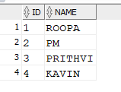

**TABLE 2:**

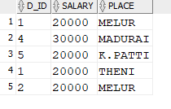

**INNER JOIN**

The INNER JOIN keyword selects all rows from both the tables as long as the condition satisfies. This keyword will create the result-set by combining all rows from both the tables where the condition satisfies i.e value of the common field will be same.

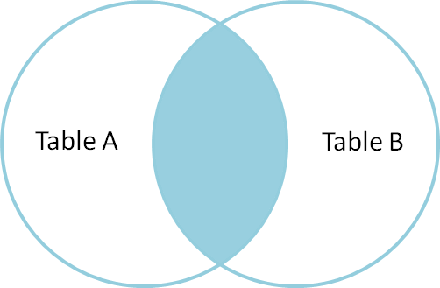

**EXAMPLE**

SELECT ID,NAME,PLACE,SALARY FROM R1 A, R2 B WHERE A.ID=B.D_ID;

**OUTPUT:**

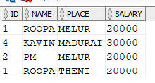

**LEFT JOIN**

This join returns all the rows of the table on the left side of the join and matching rows for the table on the right side of join. The rows for which there is no matching row on right side, the result-set will contain null. LEFT JOIN is also known as LEFT OUTER JOIN.

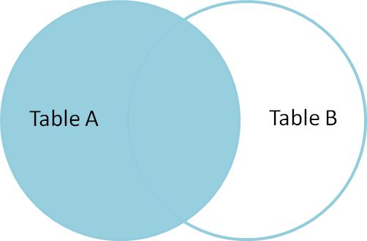

**EXAMPLE**

SELECT ID,NAME,PLACE,SALARY FROM R1 A, R2 B WHERE A.ID=B.D_ID(+);

**OUTPUT:**

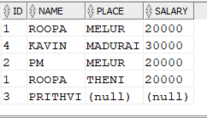

**RIGHT JOIN**

RIGHT JOIN is similar to LEFT JOIN. This join returns all the rows of the table on the right side of the join and matching rows for the table on the left side of join. The rows for which there is no matching row on left side, the result-set will contain null. RIGHT JOIN is also known as RIGHT OUTER

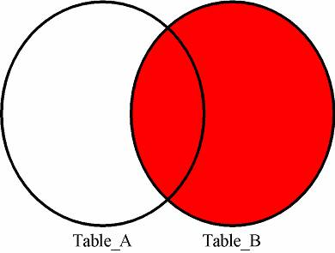

**EXAMPLE**

SELECT ID,NAME,PLACE,SALARY FROM R1 A, R2 B WHERE A.ID(+)=B.D_ID;

**OUTPUT:**

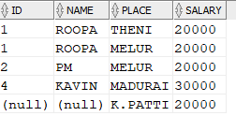

**FULL JOIN**

FULL JOIN creates the result-set by combining result of both LEFT JOIN and RIGHT JOIN. The result-set will contain all the rows from both the tables. The rows for which there is no matching, the result-set will contain NULL values.

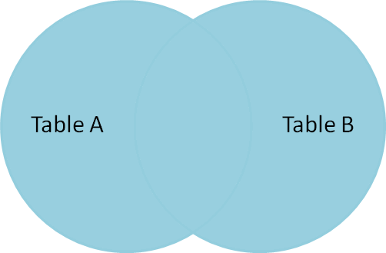

**EXAMPLE**

SELECT ID,NAME,PLACE,SALARY FROM R1 A FULL R2 B JOIN ON A.ID=B.D_ID;

**OUTPUT:**

